 | 4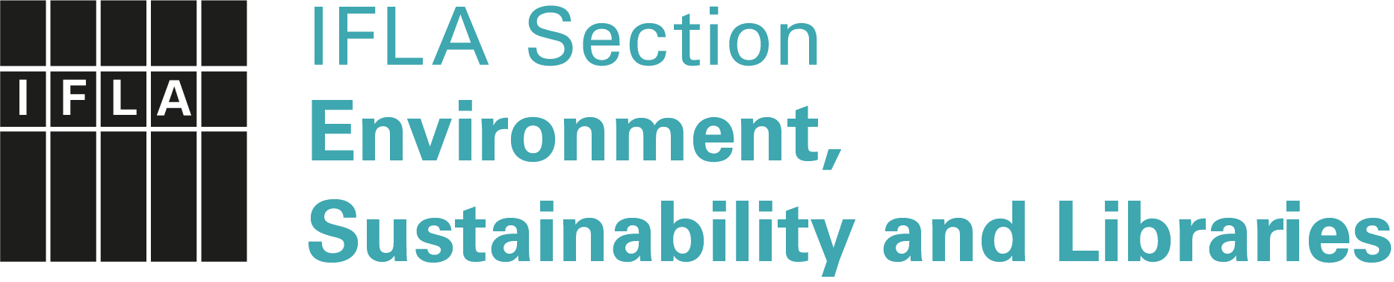
IFLA Green Library Award 2024
Application Form
Meaningful submission title
Submission type |  | ( ) essay / ( ) video / ( ) poster / ( ) article / ( ) set of slides / ( ) other: ______________________________________  Concerning ( ) an entire Green Library/Grand Scale Project  ( ) a Green Library Project
Submission language |  | ( ) English / ( ) Arabic* / ( ) Chinese* / ( ) German* /  ( ) French* / ( ) Russian* / ( ) Spanish*  *English translation required
Type of library |  | ( ) Public / ( ) School / ( ) Academic / ( ) other: …………………
Which SDGs are addressed? (Provide numbers)
Surname(s), First name(s)
Name of the library
Postal address
Email
Website
Abstract (up to 300 words, in English):
Note: if the submission is written in any other language than English, the abstract should include all relevant information.
To submit an application for the Green Library Award, send this completed form together with a detailed presentation (e.g. essay, video, poster, article, set of slides):
- Applications must be written in one of seven IFLA languages
- Applications in languages other than English must have an English translation (required)
- Film and video materials in languages other than English must have English subtitles.
- Applications should be max. 10 MB in size, unless a video is also published on YouTube.
Please send your submission electronically only, either as an email attachment, or a link via Dropbox, WeTransfer etc., no later than 28 February 2024 to:
Petra Hauke, ENSULIB SC Member, Email: petra.hauke@hu-berlin.de
and Priscilla Pun, ENSULIB Secretary, Email: nipun@um.edu.mo

