 | 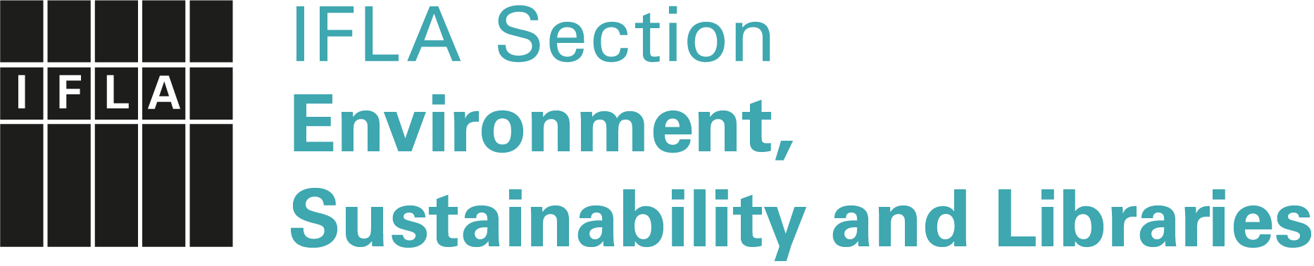
IFLA Green Library Award 2023
Application Form
Meaningful submission title
Submission type |  | ( ) essay / ( ) video / ( ) poster / ( ) article / ( ) set of slides / ( ) other: ______________________________________  Concerning ( ) an entire Green Library/Grand Scale Project  ( ) a Green Library Project
Submission language |  | ( ) English / ( ) Arabic* / ( ) Chinese* / ( ) German* /  ( ) French* / ( ) Russian* / ( ) Spanish*  *English translation required
Type of library |  | ( ) Public / ( ) School / ( ) Academic / ( ) other: …………………
Which SDGs are addressed? (Provide numbers)
Surname(s), First name(s)
Name of the library
Postal address
Email
Website
Abstract (up to 300 words, in English):

To submit an application for the Green Library Award, send this completed form together with a detailed presentation (e.g. essay, video, poster, article, set of slides):
- Applications must be written in one of seven IFLA languages
- Applications in languages other than English must have an English translation (required)
- Film and video materials in languages other than English must have English subtitles.
- Applications should be max. 10 MB in size, unless a video is also published on YouTube.

Please send your submission electronically only, either as an email attachment, or a link via Dropbox, WeTransfer etc., no later than 28 February 2023 to:
Petra Hauke, ENSULIB Secretary, Email: petra.hauke@hu-berlin.de
and Kristine Deksne, ENSULIB SC member, Email: kristine.deksne@lnb.lv

